8.88: The ratios that appear in Eq. 8.42are 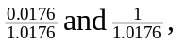so the kinetic energies are a)
Note that the energies do not add to 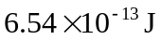exactly, due to roundoff.

